**SANYUKA CONTROL ROOM**

**Maintenance**

I conducted a maintenance of computers in Sanyuka control room through clearing browsers, configuring startup programs, cleaning keyboards, mouse and computer units, blowing and dusting off, etc.

Below are some of the pictures taken while doing maintenance of computers in sanyuka control room

**Before**

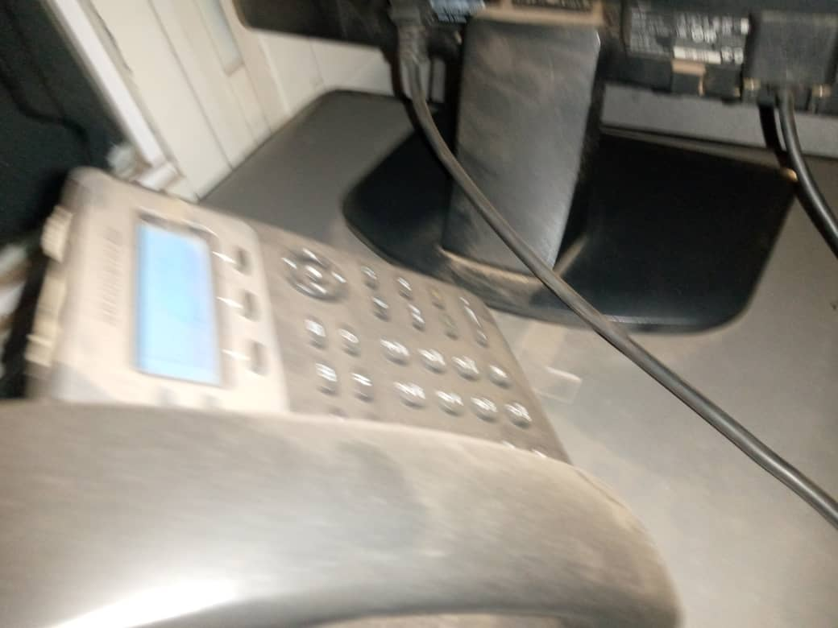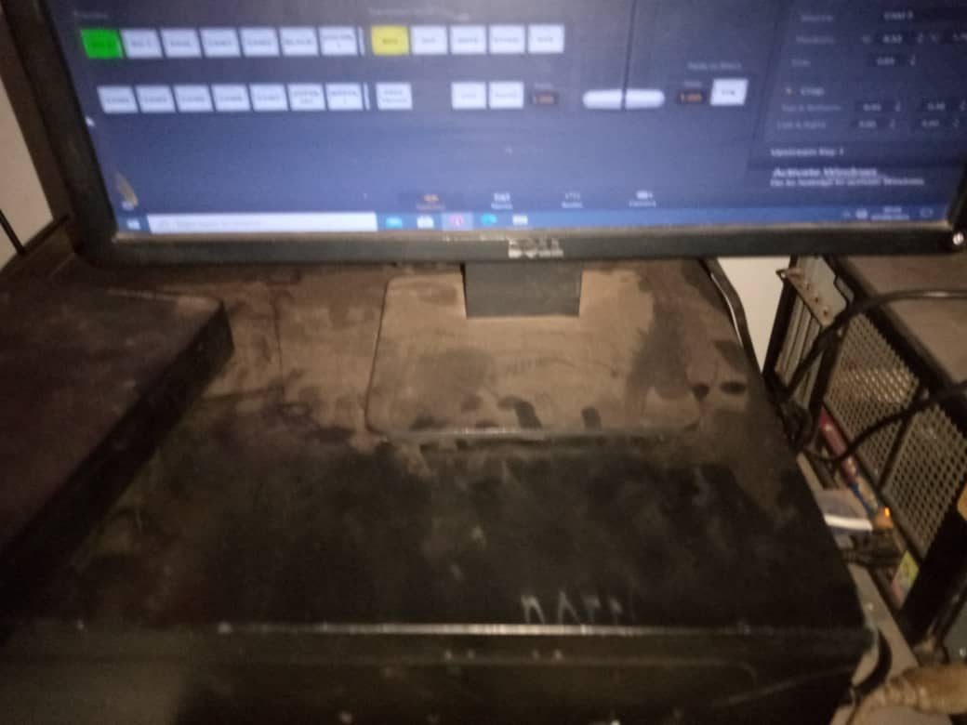

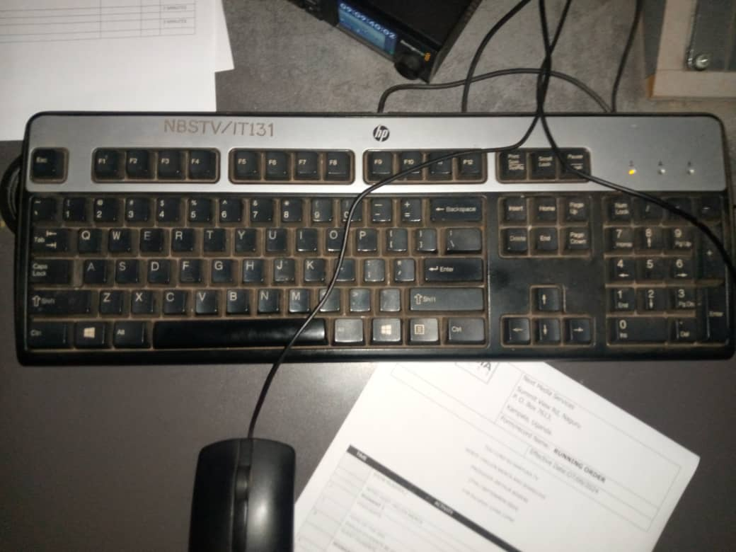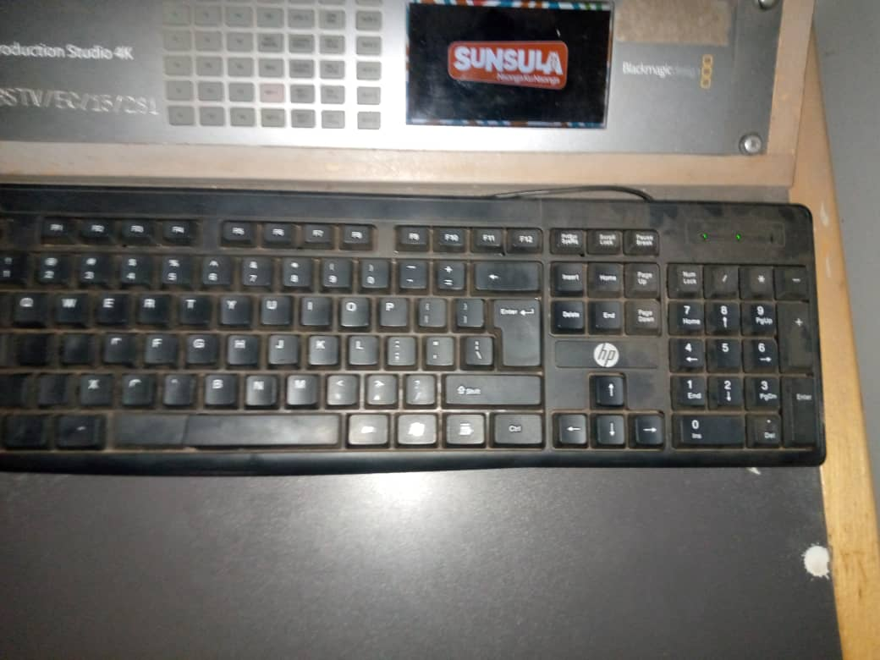

All computers are working well in sanyuka control room

**After**

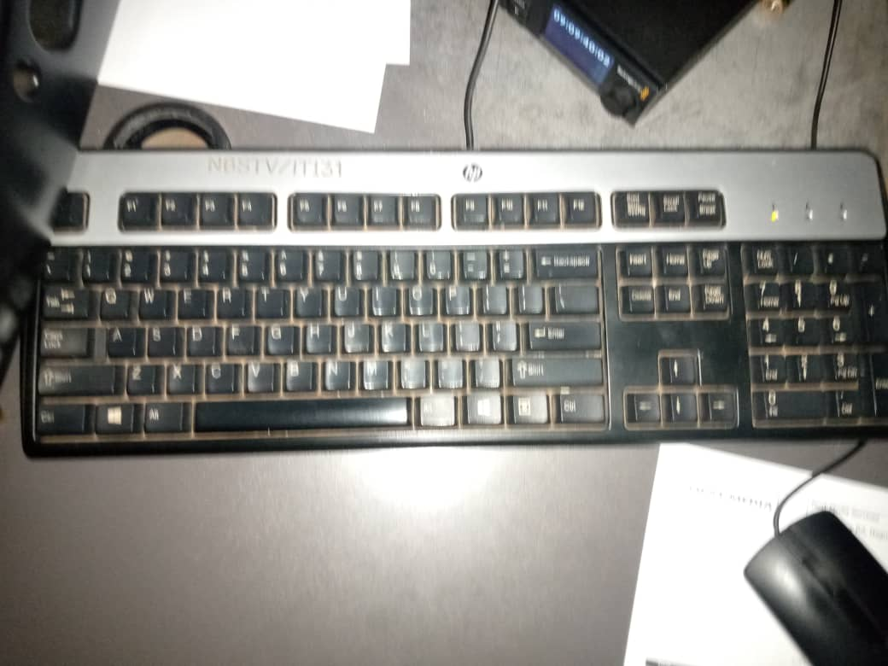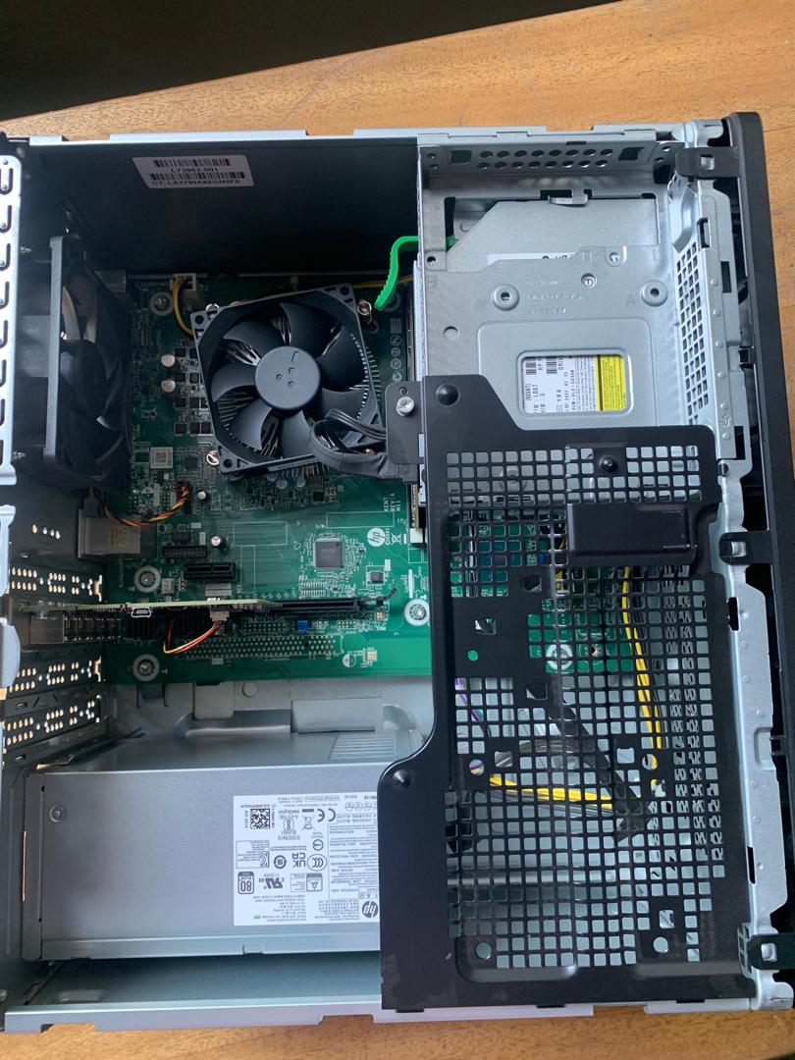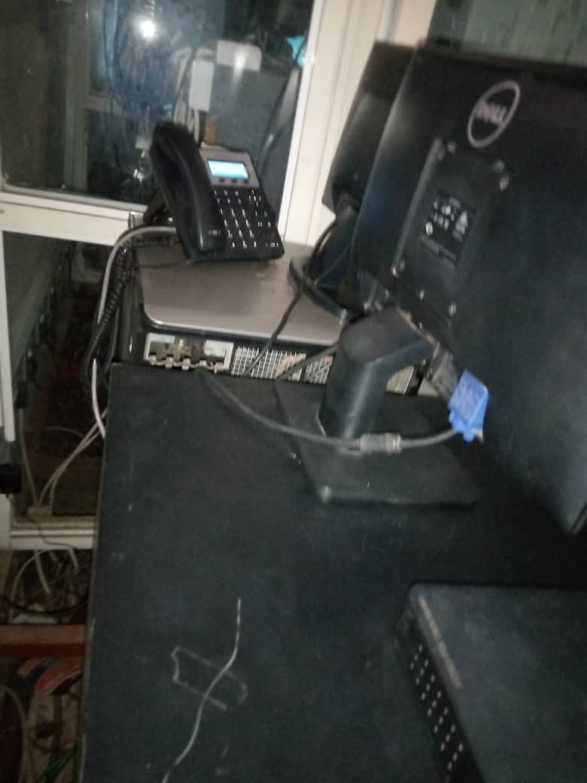

All computers are in good working conditions